Name | HANNAN MAZHAR
COURSE | ARTIFICIAL INTELLIGENCE  -Evening
INSTITUTE | TECH HUB
Repository | https://github.com/MIAN-HANNAN02/Tech-hub

CHMOD
Chmod command change the permission of a file.
We will first check the permissions of the files by ls -lIt will tell us permission of the file ind 9 digit code which is divided into 3 parts for owner,group other.first 3 digit represents owner next 3 group and last 3 others. Read has 4 value write has 2 and executed has 1
If we want to give all permission so it will become 4+2+1. So if we write 777 it will give all 3 all permission
in picture we used 755 which give all 3 permission to owner but other and group have only r and x

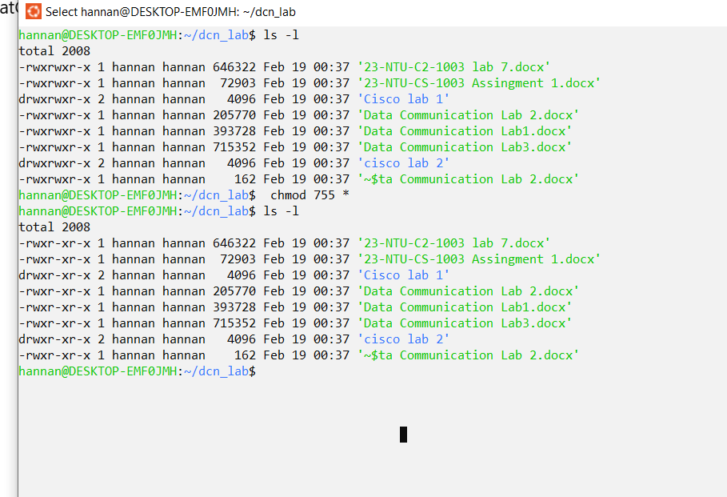

Ps
Ps stands for process status.it tell us how much time a process is taking . it tell us the time pico sec.it also tell us pts .it helps us to diagnose system performance and help us improve our system.

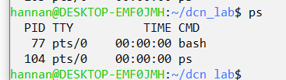

Kill id by PID
Kill id is used to terminate an ongoing process. sometiems a process is not completed and takes too long so user had to terminate it or it can be used to terminate a process that is of no benefit or taking large space.
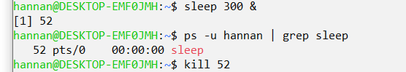

Sudo apt update
Sudo apt update upgrades the software packages too latest.you must have sudo access for it.